BECOME RESCUE
READY TO
PROVIDE
ASSISTANCE
YASA CERTRIFICATION (YMCA Aquatic Safety Assistant)
(Prerequisite for Water Fitness Instructor, if not Lifeguard certified)
Saturday, January 18th 9-5:30pm
and Sunday, January 19th 9-1:30pm
HELD AT EASTSIDE YMCA - 2101 Nagle Road, Erie, PA – (814)899-9622
YASA Registration Cost: $90 Members $110 Non-members.
YASA Cost includes: Lifeguard Manual, Resuscitation Mask, CPR, Oxygen, & First Aid Certification. For more information contact Emily Irwin at eirwin@ymcaerie.org

2101 Nagle Road Erie, PA 16510 (814)899-9622 www.ymcaerie.org
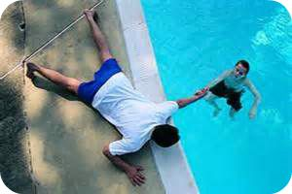
Prerequisite Swim: Saturday, January 11th @ 12pm
Cost: $30 members, $40 Non-members (non-refundable) Registration: Open and available now. Minimum age is 14 years.
Prerequisites: Complete Physical Competency Requirements
Phase1
  - Tread water for 2 minutes using legs only
  - Swim 100 yards of front crawl
Phase 2
  - Starting in the shallow end of the water, sprint for a distance of approximately 60 feet then perform an arm-over-arm surface dive in 8-10 feet (or maximum depth of training facility).
  - Pick up an object from the bottom of pool, surface and tread water for at lease one minute with legs only, replace the object back to the bottom of the pool where it was found.
  - Swim the remaining length to the end of the pool and hoist yourself out of the water.
  - Immediately begin compression on an adult manikin for one minute or 100 compressions, stand and listen to directions for instructor.
*Note* if you pass the prerequisite swim you will be able to register for the YASA course following the prerequisite swim. If you do not pass you will not be permitted to sign up for the YASA course.

